**Treatment Price List**

**Body Treatment**

* Crystalignment Massage – 90 minutes, £90.00
* Structural Rebalancing:
  + 1. Initial consultation and treatment – 90 minutes, £90.00
    2. Continuing treatments – 75 minutes, £80.00
* Aromatherapy Body Massage – 75 minutes, £80.00
* Hot Stone Massage – 75 minutes, £80.00
* 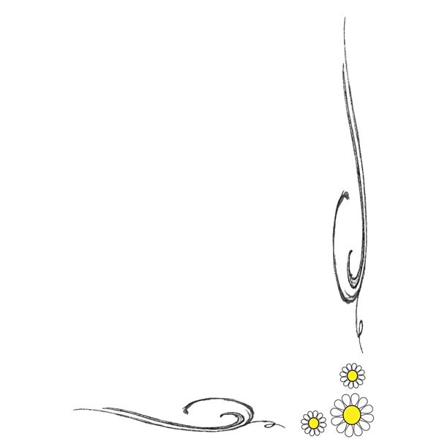Deep Tissue Massage – 90 minutes, £90.00; 75 minutes, £80.00
* Lymphatic Drainage Massage – 75 minutes, £80.00
* Body Massage – 75 minutes, £80.00
* Body Massage – 90 minutes, £90.00
* Body Massage – 120 minutes, £120.00
* Detoxifying Body Massage – 75 minutes, £80.00
* Back and Shoulder Massage – 60 minutes, £70.00
* Full Body Pamper (Scrub & Massage) – 120 minutes, £130.00

**Facials:**

* Aromatherapy Facial; 60 minutes, £70.00

**Cacao Ceremonies**

* Per person - £30.00

**Holistic Healing Treatments**

* Counselling - £65 per hour
* Embodied Alchemy - £155 for 150 minutes
* Shamanic & Energy Healing - £70 per hour
* Distance Healing - £60.00
* Thai Foot Massage – 60 minutes, £70.00
* Indian Head Massage – 60 minutes, £70.00
* Reiki & Angelic Reiki:

Initial consultation and treatment – 90 minutes, £90.00

****Continuing treatments – 60 minutes, £70.00

* Thermal Auricular Therapy/Hopi Ear Candle – 60 minutes, £70.00
* Crystal Healing:

Initial consultation and treatment – 90 minutes, £90.00

Continuing treatments – 60 minutes, £70.00

**Reiki Training:**

* Reiki I - £350.00
* Reiki II - £450.00
* Reiki Master - £550.00

Lorna Benbow: 07818 644094

[Lorna@qwb.me](mailto:Lorna@qwb.me). <http://qwb.me>