Treatment Price List

Beauty Treatments

Facials:
- Prescription Facial; 60 minutes, £52.00
- Aromatherapy Facial; 60 minutes, £55.00

Pamper Sessions:
- Luxury Manicure – 60 minutes, £37.00
- Luxury Pedicure – 60 minutes, £37.00

Waxing:
- Full leg – 40 minutes, £33.00
- Half leg – 20 minutes, £23.00
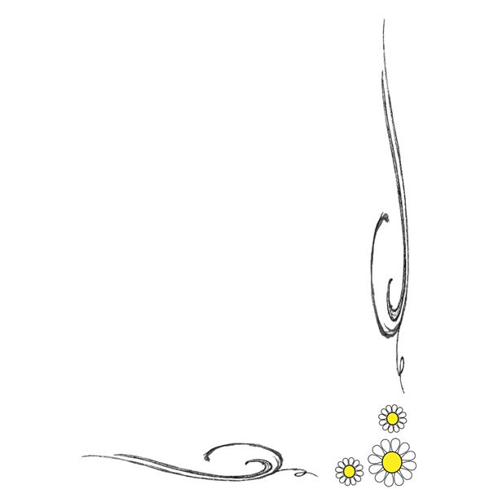
- 3/4 leg – 30 minutes, £29.00
- Bikini or underarm – 20 minutes, £17.00
- Lip or chin – 10 minutes, £16.00

Beauty Appointments:
- Revive Facial – 40 minutes, £37.00
- Eyebrow Shaping – 10 minutes, £16.00
- Eyebrow or Eyelash Tinting – 10 minutes, £17.00

Shellac Nails:
- Cuticle, file, exfoliation, paint – 60 minutes, £40.00
- Removal & repair – 30 minutes, £20.00
- Removal & condition – 20 minutes, £14.00

Reiki Training:
- Reiki I - £153.00
- Reiki II - £198.00
- Reiki Master - £305.00

Body Treatment
- Crystalignment Massage – 90 minutes, £79.00
- Structural Rebalancing:
    - Initial consultation and treatment – 90 minutes, £78.00
    - Continuing treatments – 70 minutes, £60.00
- Aromatherapy Body Massage – 75 minutes, £60.00
- Hot Stone Massage – 75 minutes, £65.00
- Deep Tissue Massage – 90 minutes, £79.00; 70 minutes, £58.00
- Lymphatic Drainage Massage – 60 minutes, £53.00
- Body Massage – 75 minutes, £60.00
- Body Massage – 90 minutes, £72.00
- Detoxifying Body Massage – 70 minutes, £60.00
- Back and Shoulder Massage – 60 minutes, £50.00
- Full Body Scrub – 30 minutes, £39.00
- Full Body Pamper (Scrub & Massage) – 90 minutes, £82.00

Holistic Healing Treatments
- Shamanic & Energy Healing - £60 per hour
- Distance Healing - £40.00
- Thai Foot Massage – 60 minutes, £50.00
- Indian Head Massage – 45 minutes, £45.00
- Reiki & Angelic Reiki:
Initial consultation and treatment – 90 minutes, £72.00
Continuing treatments – 60 minutes, £56.00
- Thermal Auricular Therapy/Hopi Ear Candle – £47.00
- Crystal Healing:
Initial consultation and treatment – 90 minutes, £72.00
Continuing treatments – 60 minutes, £56.00
  - Interactive Tarot Reading – 45 minutes, £40.00

Lorna Benbow: 07818 644094
Lorna@qwb.me : www.quiescencewellbeing.co.uk.

